

Functional Safety Concept Lane Assistance

**Document Version:** 2.0



# Document history

|  |  |  |  |
| --- | --- | --- | --- |
| Date | Version | Editor | Description |
| 12/3/17 | 1.0 | Vatche Donikian | First submission attempt |
| 12/18/17 | 2.0 | Vatche Donikian | Second Submission |
|  |  |  |  |
|  |  |  |  |
|  |  |  |  |

# 

# Table of Contents

Document history

Table of Contents

Purpose of the Functional Safety Concept

Inputs to the Functional Safety Analysis

Safety goals from the Hazard Analysis and Risk Assessment

Preliminary Architecture

Description of architecture elements

Functional Safety Concept

Functional Safety Analysis

Functional Safety Requirements

Refinement of the System Architecture

Allocation of Functional Safety Requirements to Architecture Elements

Warning and Degradation Concept

# Purpose of the Functional Safety Concept

The functional safety concept is used to identify new requirements and allocate these requirements to system diagrams. This concept takes Safety goals and turns them into high-level requirements to reduce hazardous risks to acceptable levels.

# Inputs to the Functional Safety Concept

## Safety goals from the Hazard Analysis and Risk Assessment

|  |  |
| --- | --- |
| **ID** | **Safety Goal** |
| Safety_Goal_01 | The oscillating steering torque from the lane departure warning function shall be limited. |
| Safety_Goal_02 | The lane keeping assistance function shall be time limited and the additional steering torque shall end after a given time interval so that the driver cannot misuse the system for autonomous driving. |

## Preliminary Architecture

The preliminary architecture of the lane assistance item consists of the camera sensor and its ECU, the car display and its ECU, the driving steering torque sensor, the electronic power steering ECU, and the motor providing torque to the steering wheel.

### Description of architecture elements

|  |  |
| --- | --- |
| **Element** | **Description** |
| Camera Sensor | Captures images of the road |
| Camera Sensor ECU | Determines when the vehicle is leaving the lane |
| Car Display | Lights up to notify driver of lane departure |
| Car Display ECU | Determines when to turn lights on in the dash |
| Driver Steering Torque Sensor | Determines the amount, if any, that the driver is steering |
| Electronic Power Steering ECU | Determines the amount of torque request to send to the motor |
| Motor | Provides torque to the steering wheel |

# Functional Safety Concept

The functional safety concept consists of:

* Functional safety analysis
* Functional safety requirements
* Functional safety architecture
* Warning and degradation concept

## Functional Safety Analysis

|  |  |  |  |
| --- | --- | --- | --- |
| **Malfunction ID** | **Main Function of the Item Related to Safety Goal Violations** | **Guidewords (NO, WRONG, EARLY, LATE, MORE, LESS)** | **Resulting Malfunction** |
| Malfunction_01 | Lane Departure Warning (LDW) function shall apply an oscillating steering torque to provide the driver a haptic feedback | MORE | The lane departure warning function applies an oscillating torque with very high torque amplitude (above limit) |
| Malfunction_02 | Lane Departure Warning (LDW) function shall apply an oscillating steering torque to provide the driver a haptic feedback | MORE | The lane departure warning function applies an oscillating torque with very high torque frequency (above limit) |
| Malfunction_03 | Lane Keeping Assistance (LKA) function shall apply the steering torque when active in order to stay in ego lane | NO | The lane keeping assistance function is not limited in time duration which leads to misuse as an autonomous driving function. |

## Functional Safety Requirements

Lane Departure Warning (LDW) Requirements:

|  |  |  |  |  |
| --- | --- | --- | --- | --- |
| **ID** | **Functional Safety Requirement** | **ASIL** | **Fault Tolerant Time Interval** | **Safe State** |
| Functional  Safety  Requirement  01-01 | The EPS ECU shall ensure that the lane departure warning torque amplitude is below Max_Torque_Amplitude | C | 50 ms | Turn function off |
| Functional  Safety  Requirement  01-02 | The EPS ECU shall ensure that the lane departure torque frequency is below Max_Torque_Frequency | C | 50 ms | Turn function off |

Lane Departure Warning (LDW) Verification and Validation Acceptance Criteria:

|  |  |  |
| --- | --- | --- |
| **ID** | **Validation Acceptance**  **Criteria and Method** | **Verification Acceptance**  **Criteria and Method** |
| Functional  Safety  Requirement  01-01 | Choose a maximum torque amplitude, and test how drivers react to different torque amplitudes to prove that we chose an appropriate value. | When the torque amplitude crosses the limit, the lane assistance output should set to zero within the 50 ms fault tolerant time interval. Perform a software test inserting a fault into the system and seeing what happens. |
| Functional  Safety  Requirement  01-02 | Choose a maximum torque frequency, and test how drivers react to different torque frequencies to prove that we chose an appropriate value. | When the torque frequency crosses the limit, the lane assistance output should set to zero within the 50 ms fault tolerant time interval. Perform a software test inserting a fault into the system and seeing what happens. |

Lane Keeping Assistance (LKA) Requirements:

|  |  |  |  |  |
| --- | --- | --- | --- | --- |
| **ID** | **Functional Safety Requirement** | **ASIL** | **Fault Tolerant Time Interval** | **Safe State** |
| Functional  Safety  Requirement  02-01 | The electronic power steering ECU shall ensure that the lane keeping assistance torque is applied for only Max_Duration. | B | 500 ms | Turn function off |

Lane Keeping Assistance (LKA) Verification and Validation Acceptance Criteria:

|  |  |  |
| --- | --- | --- |
| **ID** | **Validation Acceptance**  **Criteria and Method** | **Verification Acceptance**  **Criteria and Method** |
| Functional  Safety  Requirement  02-01 | Define a maximum duration time for the system and then test and validate that the max_duration chosen really did dissuade drivers from taking their hands off the wheel. | Test on drivers and vehicles that the system really does turn off if the lane keeping assistance every exceeded max_duration. |

## Refinement of the System Architecture

The refined system architecture is shown below. Subsystem components can be classified by the ASIL score of their corresponding safety requirements. Also, the components can be split into different ASIL risk parts.

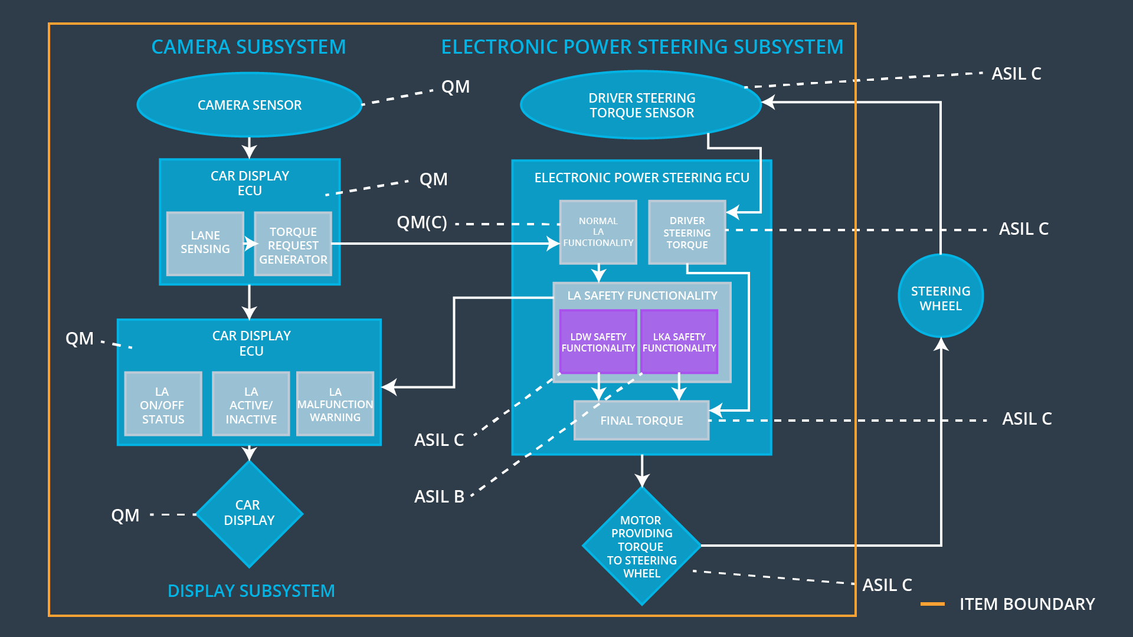

## Allocation of Functional Safety Requirements to Architecture Elements

|  |  |  |  |  |
| --- | --- | --- | --- | --- |
| **ID** | **Functional Safety Requirement** | **Electronic Power Steering ECU** | **Camera ECU** | **Car Display ECU** |
| Functional  Safety  Requirement  01-01 | The lane keeping item shall ensure that the lane departure oscillating torque amplitude is below Max_Torque_Amplitude | **Yes** |  |  |
| Functional  Safety  Requirement  01-02 | The lane keeping item shall ensure that the lane departure oscillating torque frequency is below Max_Torque_Frequency | **Yes** |  |  |
| Functional  Safety  Requirement  02-01 | The electronic power steering ECU shall ensure that the lane keeping assistance torque is applied for only Max_Duration. | **Yes** |  |  |

## Warning and Degradation Concept

|  |  |  |  |  |
| --- | --- | --- | --- | --- |
| **ID** | **Degradation Mode** | **Trigger for Degradation Mode** | **Safe State invoked?** | **Driver Warning** |
| WDC-01 | Turn off functionality | Malfunction_01 & Malfunction_02 | Yes | Warning light on the dash |
| WDC-02 | Turn off functionality | Malfunction_03 | Yes | Warning light on the dash |